Las Vegas - LUXURY HOMES

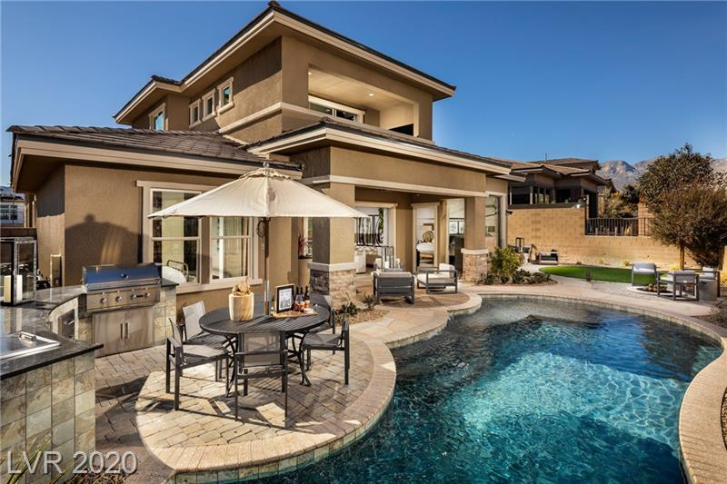

LP $828,995, 4BR/5B, Shadow Pt, Summerlin

|  |  |
| --- | --- |
|  |  |

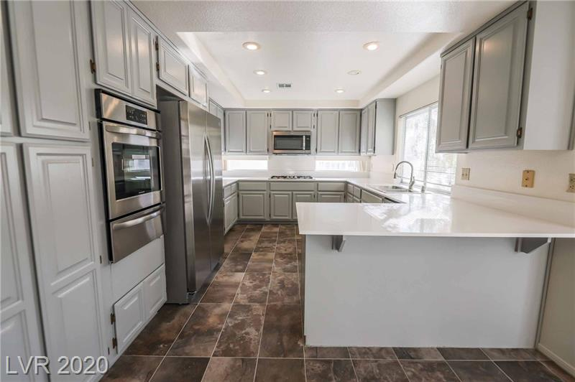 LP starting at $429,000 5BR/3B, South Shore, Henderson

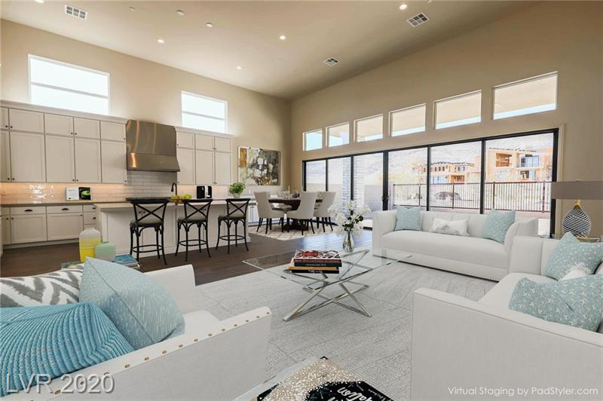

LP staring at $1,049,995, 4BR/ 5B, Summerlin Village

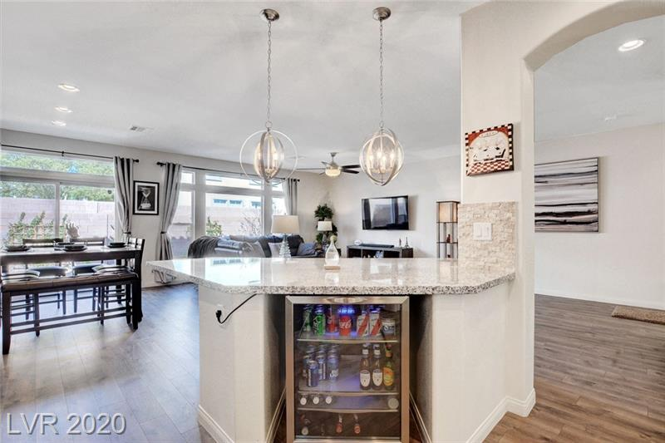

LP starting at $359, 4BR/3B, Warm Springs, Las Vegas

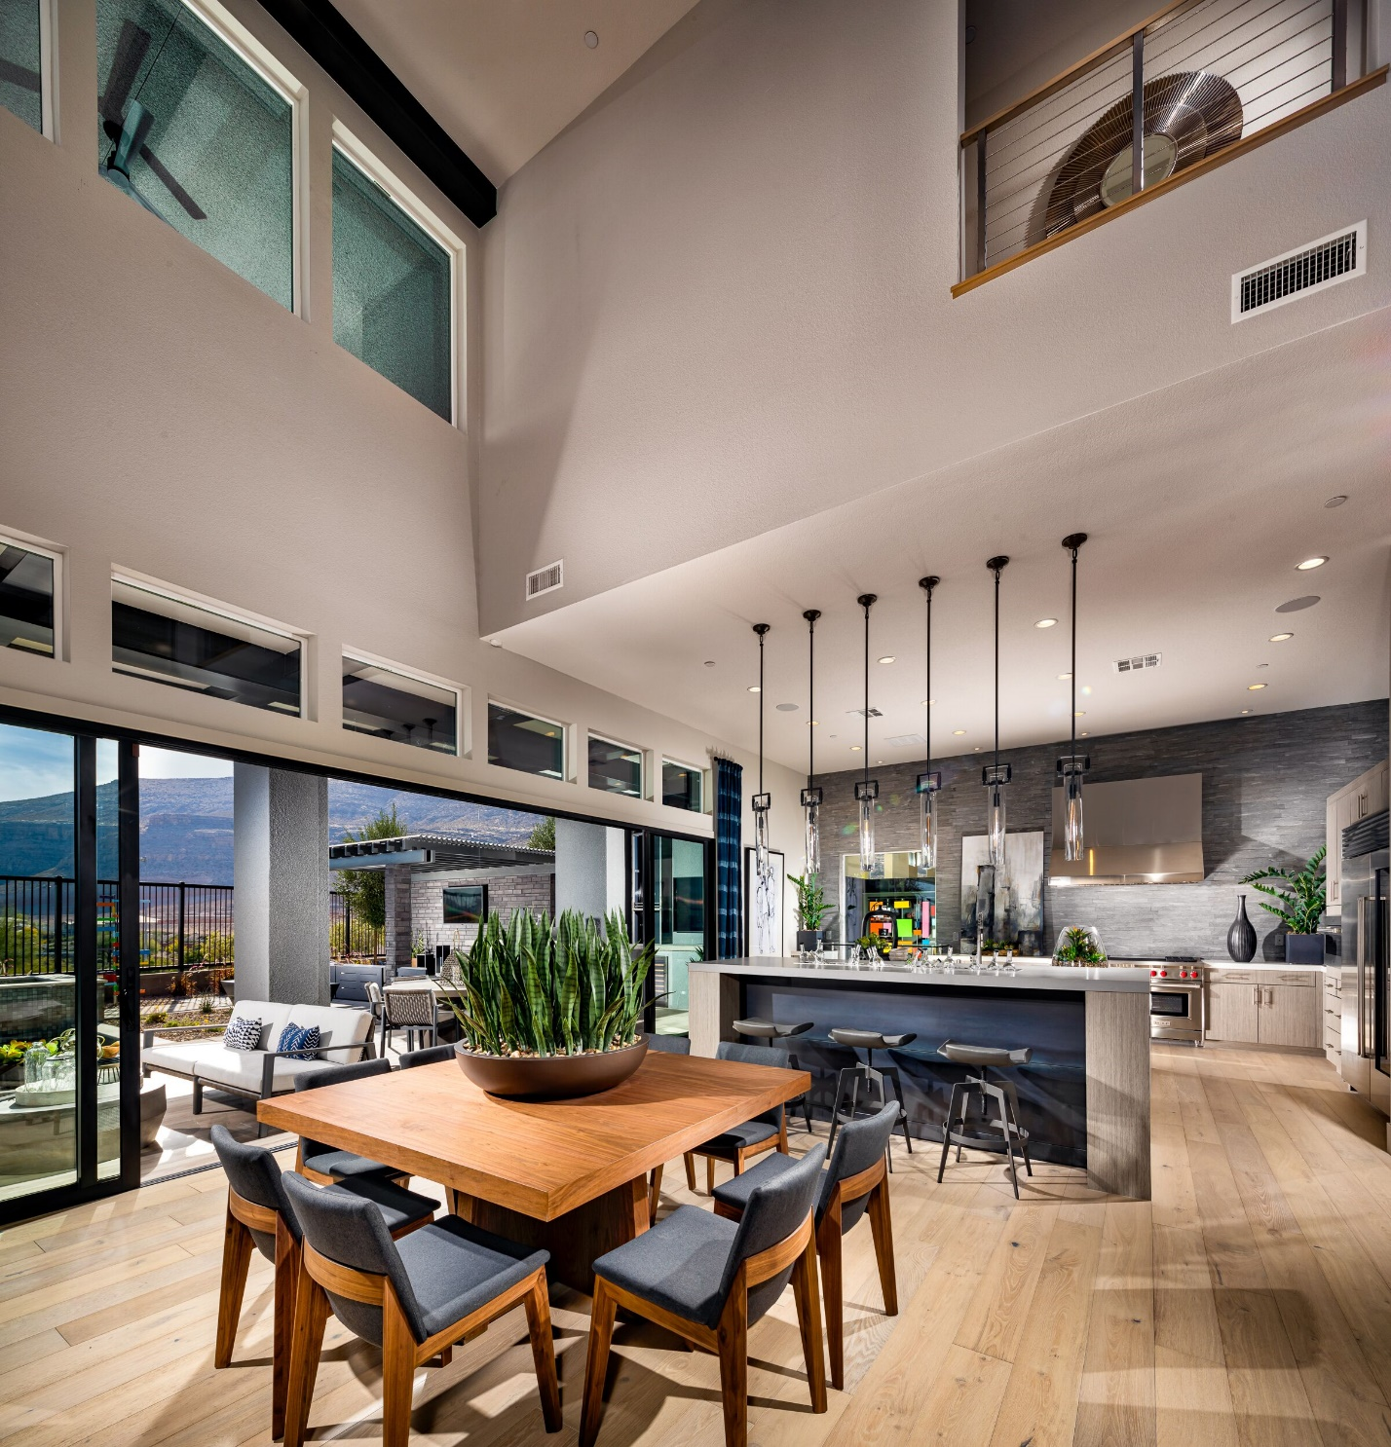

LP starting at $873,995, Mesa Ridge, Summerlin